10.52: a) The net torque must be
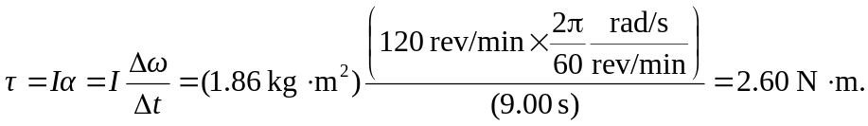
This torque must be the sum of the applied force 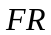 and the opposing frictional torques
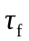 at the axle and 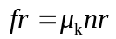due to the knife. Combining,

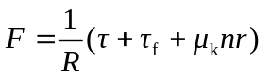
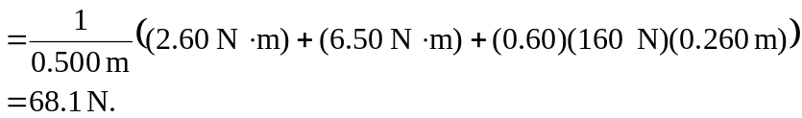

b) To maintain a constant angular velocity, the net torque is zero, and the force 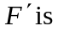 c) The time t needed to come to a stop is found by taking the magnitudes in Eq. (10.27), with 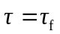 constant;

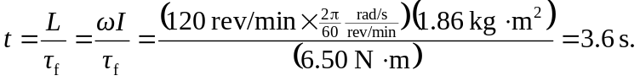

Note that this time can also be found as 